Project Report
On
ONLINE LIBRARY

Submitted by:
ARYAN (2401010005)
AMAN (2401010141)
MAHIN (2401010123)
BHAVIK (2401010039)

Department of
Computer Science and Engineering

School of Engineering and Technology
K. R. Mangalam University, Gurugram- 122003

Index
Topic | Page Number
Abstract | i
1. Introduction | 1
1.1 Background | 1
1.2 Project Objectives | 2
1.3 Scope | 2
2. Technology Overview | 3
2.1 HTML5 & CSS3 | 3
2.2 NODE.JS | 4
2.3 SQL | 5
3. Project Implementation | 10
4. Key Features Developed | 13
5. Screenshots | 14
6. Conclusion and Future Work | 18
7. References | 20

Abstract

The LibroHub is a web-based system designed to offer users seamless access to a global collection of digital books. It aims to bridge the gap between readers and resources by providing an efficient, user-friendly, and scalable platform where books can be browsed, rented, and read online. The system integrates modern web technologies such as HTML5, CSS3, Node.js, and SQL to deliver a responsive, secure, and data-driven environment. Admins manage the digital library by adding, categorizing, and approving books for rent, while users can register, log in, and request access to books. The platform supports dynamic content management, real-time data handling, and structured storage, ensuring data integrity and a smooth user experience. The project demonstrates how technology can revolutionize traditional library systems, promoting global literacy and accessibility. It highlights the potential of web development frameworks and database management in creating an organized, interactive, and scalable digital ecosystem for knowledge sharing.

Introduction

Libraries have always been crucial sources of knowledge and information. However, traditional libraries often face challenges such as limited physical space, restricted access times, and geographical limitations. With advancements in web technologies, online libraries have emerged as innovative solutions that overcome these constraints. The Online Library Website provides a centralized platform that allows users to explore, rent, and read books anytime, anywhere. The system simplifies book management for administrators and enhances reading convenience for users. By leveraging modern technologies like HTML, CSS, Node.js, and SQL, this platform ensures that users experience an efficient and interactive digital reading environment. Moreover, it aligns with the global shift toward digitization in education and resource sharing, promoting open access to information and supporting lifelong learning.

1.1 Background
The concept of digital libraries dates back to the early 1990s, but with the evolution of web technologies, the idea has transformed into sophisticated, interactive platforms. Traditional libraries required users to physically visit locations, often limited by time, space, and availability. The increasing dependency on the internet for learning and research has created a strong demand for online resources. The Online Library Website was conceptualized to meet this need, enabling users to explore a vast collection of books from various domains through a single web interface. Unlike static repositories, the proposed system incorporates real-time data management, secure authentication, and user-specific permissions. It not only digitizes the process of book management but also fosters global connectivity among learners, educators, and institutions. This transformation from physical to virtual libraries marks a significant leap toward creating inclusive, technology-driven knowledge systems.

1.2 Project Objectives
The primary objectives of the LibroHub are as follows:
• To develop a fully functional web platform for accessing digital books globally.
• To provide an intuitive interface for users and administrators.
• To ensure secure login, registration, and book rental mechanisms.
• To design an efficient database using SQL for managing users, books, and transactions.
• To implement backend functionality using Node.js for handling requests and server operations.
• To enhance accessibility through responsive web design using HTML5 and CSS3.
• To reduce the dependency on physical libraries and promote e-learning.
• To support scalability and easy integration of new features in the future.

1.3 Scope
The scope of this project encompasses both technical and practical aspects. From a technical standpoint, it includes the use of web technologies to create a full-stack application that can manage thousands of users and books efficiently. Practically, it aims to serve educational institutions, students, and individuals seeking convenient access to knowledge. The system supports book uploads, categorization, user authentication, and rental management. The scope also extends to maintaining user logs, ensuring data security, and providing role-based access. In future enhancements, AI-driven recommendations, cloud integration, and multilingual support could be added to broaden the system’s reach and usability.

2. Technology Overview

2.1 HTML5 & CSS3
HTML5 forms the structural backbone of the LibroHub. It provides the semantic layout for web pages, enabling consistent and accessible design. The use of HTML5 ensures that the application adheres to modern web standards, supporting multimedia, forms, and responsive design elements. CSS3 is employed for styling, layout customization, and responsiveness. Through CSS3, the website achieves visual consistency and mobile compatibility. Features like transitions, grids, and media queries improve usability across devices. Together, HTML5 and CSS3 provide a solid foundation for creating a visually appealing and functional interface that enhances user engagement.

2.2 Node.js
Node.js is the runtime environment used for server-side development in the LibroHub. It enables asynchronous, event-driven programming, making it ideal for handling multiple user requests efficiently. Node.js interacts with the database to process book rentals, user authentication, and other dynamic operations. Its lightweight architecture supports scalability and high performance. With frameworks such as Express.js, the backend is structured to handle routing, API development, and middleware management. This ensures that the communication between the client and server remains fast, secure, and reliable.

2.3 SQL
SQL serves as the backbone for data storage and retrieval in the system. It manages relational data for books, users, and rentals through structured tables. SQL queries enable efficient execution of CRUD (Create, Read, Update, Delete) operations. Proper indexing and normalization improve data consistency and minimize redundancy. The database also ensures role-based access control, where user privileges differ from those of administrators. SQL’s reliability and integrity features make it ideal for maintaining long-term storage and transaction history in the LibroHub.

Project Implementation

The implementation of the Librohub involves several systematic phases. The first phase is requirement analysis, during which system needs were defined and architectural decisions were made. The design phase focused on creating wireframes and defining database schemas. The development phase integrated frontend and backend components. HTML and CSS were used to create a responsive layout, while Node.js handled user authentication, book requests, and admin functions. The SQL database stored user and book information, ensuring efficient data retrieval. Testing was conducted to ensure system reliability and eliminate bugs. Finally, deployment made the system accessible to users via a web server. The project follows modular design principles, allowing each component to be independently updated or scaled in the future.

Key Features Developed

The LibroHub includes multiple advanced features that enhance functionality and user interaction:
• User registration, login, and secure authentication.
• Admin dashboard for managing books, categories, and users.
• Search functionality with keyword-based filtering.
• Book rental management with real-time updates.
• Responsive web interface for mobile and desktop compatibility.
• SQL-based data persistence ensuring secure storage.
• RESTful API integration for efficient communication between frontend and backend.
• Scalable architecture supporting future feature expansion.

5. Screenshots

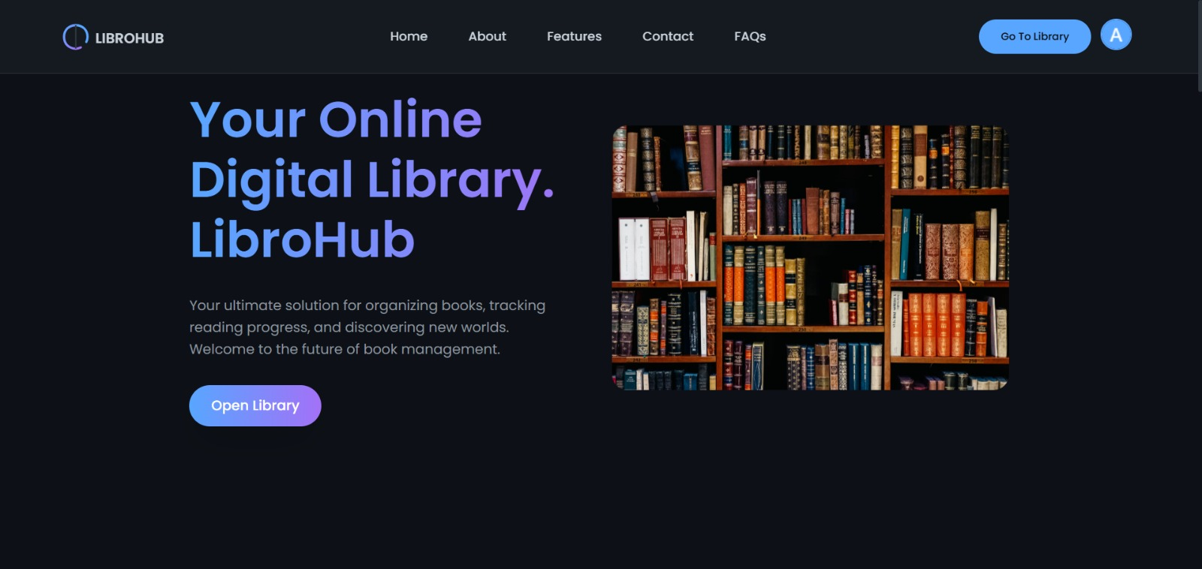

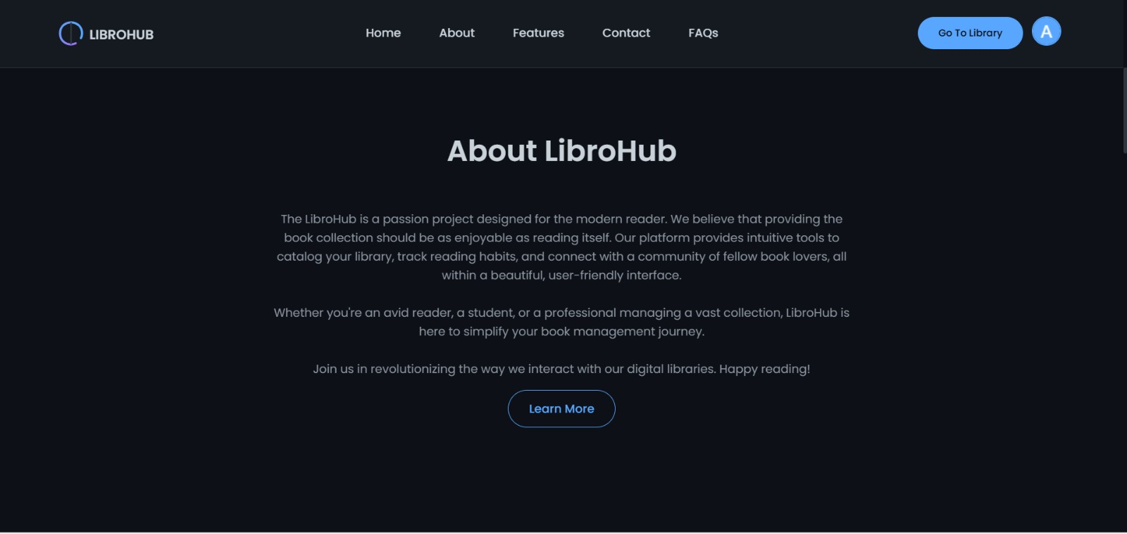

- LOGIN AND REGISTRATION
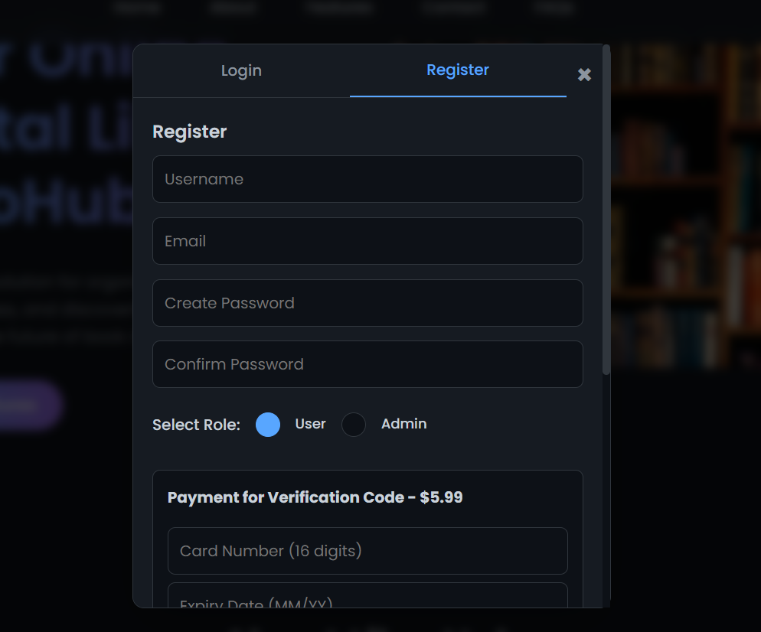
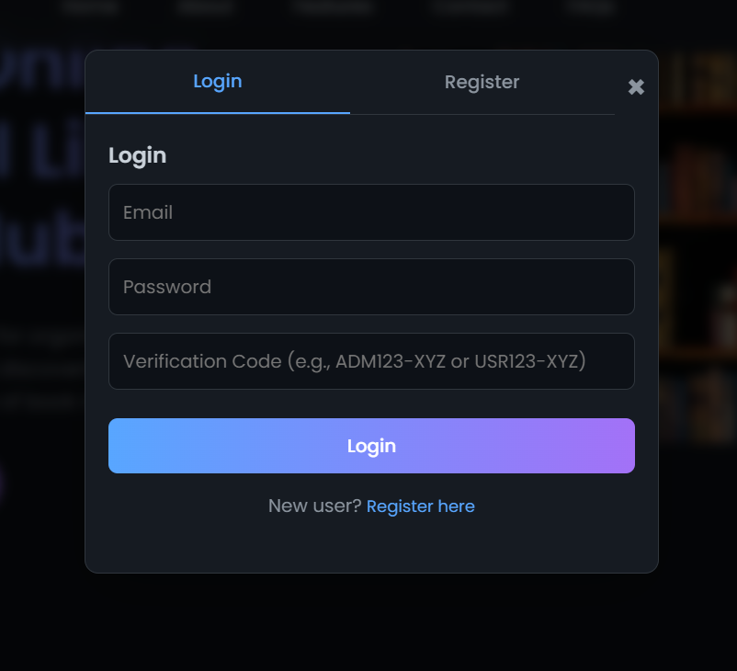

- DASHBOARD

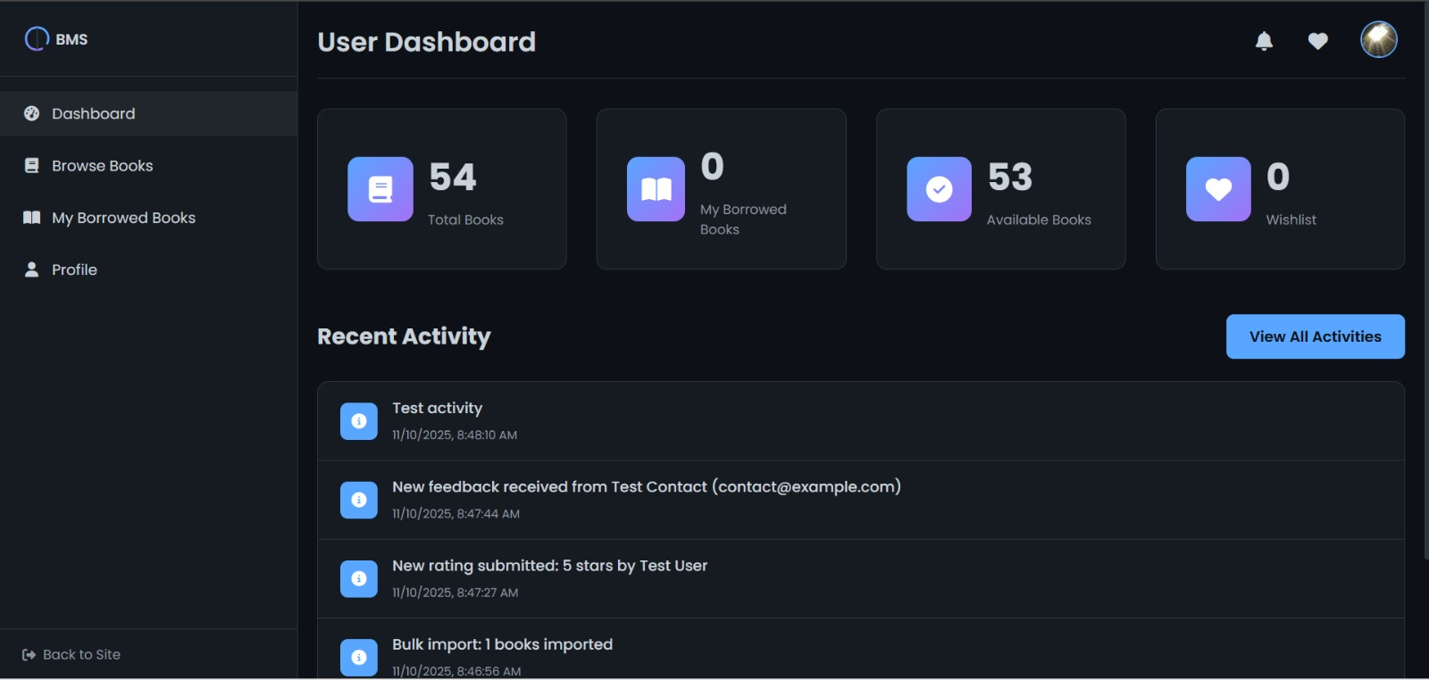
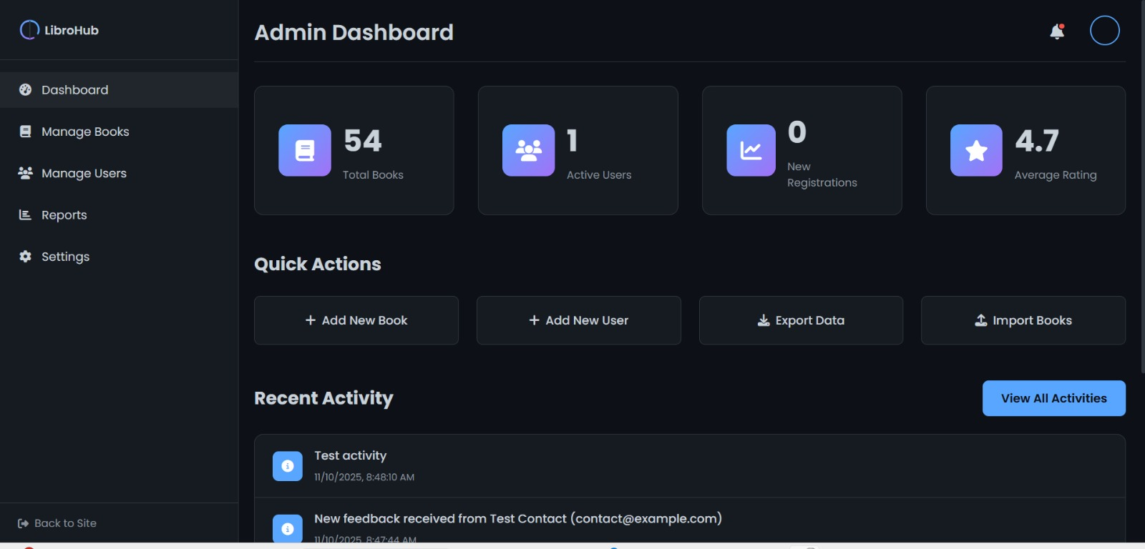

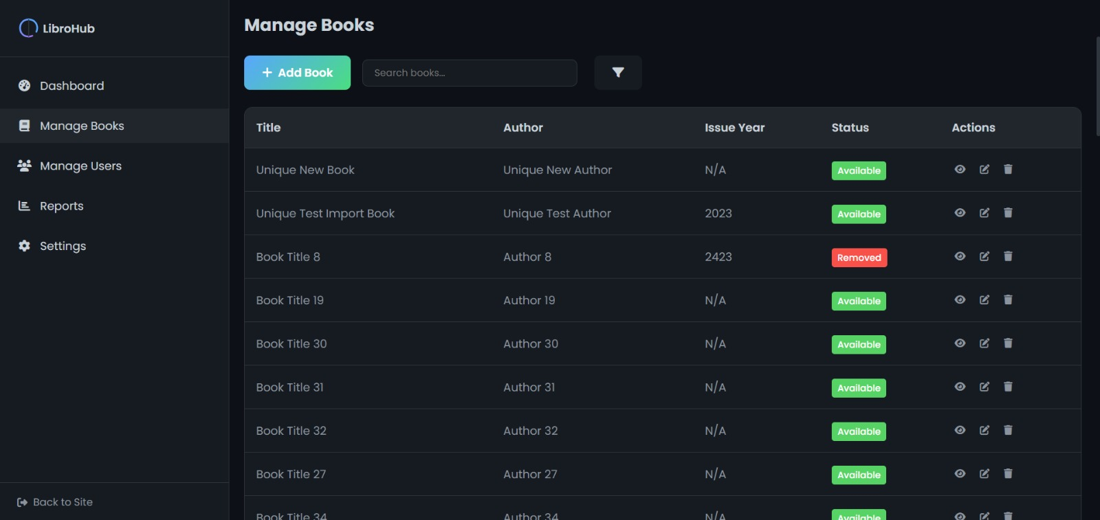
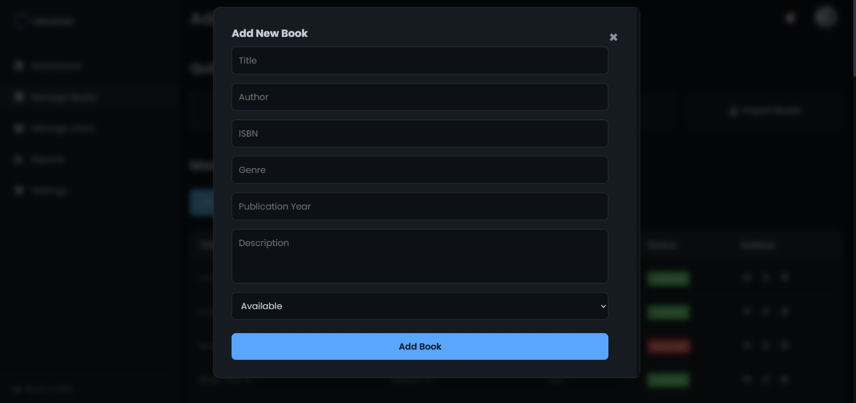
- FEATURES

6. Conclusion and Future Work
The LibroHub project successfully achieves its objective of creating a modern, efficient, and user-friendly digital library platform. It demonstrates the effective integration of web technologies such as HTML5, CSS3, Node.js, and SQL to deliver a scalable and secure system. The application addresses the limitations of traditional libraries and promotes remote accessibility to knowledge resources. The admin-controlled renting mechanism ensures that the platform remains organized and reliable. In future developments, the system can incorporate artificial intelligence to recommend books, natural language processing for improved search results, and cloud-based services for better scalability. This project sets a foundation for future innovations in the field of digital education and online resource management.

7. References
1. W3Schools. (2025). HTML and CSS Tutorials. https://www.w3schools.com
2. Node.js Documentation. (2025). https://nodejs.org
3. MySQL Official Documentation. (2025). https://dev.mysql.com
4. MDN Web Docs. (2025). https://developer.mozilla.org
5. Express.js Guide. (2025). https://expressjs.com

GITHUB LINK : https://github.com/Aman-Code31/library-system.git

